Interactive financial literacy user empowerment platform
Gallapalli Sathar¹, A. Niharika², P. Anmol³, B. Bhuvanesh Gupta⁴, Faiz⁵, G. Sanath⁶, M. Manjula⁷, M. Viditha⁸, M. Vinayasree⁹, P. Navaneeth¹⁰, T. Srija¹¹, G. Siri Chandana¹², R. Rishika¹³, M. Supreeth¹⁴, R. Sudha¹⁵
Sathar9000@gmail.com,niharkaambewar55@gmail.com, malothmanjula43@gmail.com, podduturinavaneethreddy@gmail.com, tadurisrija5@gmail.com, viditha47@gmail.com, sirichandanareddy5767@gmail.com, rishikareddi2007@gmail.com, mvinayasree6@gmail.com, supreethmaraveena@gmail.com, faiz.online06@gmail.com, bbhuvaneshgupta@gmail.com,sanathkumar.ganapurapu@gmail.com, anmolpynampuram@gmail.com, sudhareddepogu@gmail.com

ABSTRACT: Financial illiteracy remains a major challenge among students and young adults, leading to poor budgeting habits, emotional spending, debt accumulation, and vulnerability to financial scams. To address this gap, this project proposes an Interactive Financial Literacy and Consumer Empowerment Platform designed to make financial education simple, engaging, and practical. The platform integrates gamified learning modules, real-life financial simulators for budgeting, EMI calculation, and investing, as well as an AI-powered personal financial mentor. Additional features include smart expense tracking, goal-based financial planning, group expense settlement, and a fraud-awareness system. The solution is built using widely available technologies such as React, Node.js, and AI-based NLP tools, ensuring scalability and feasibility. With increasing demand for personal finance education and strong support from institutions and government initiatives, the platform aims to enhance financial awareness, improve decision-making, and foster long-term financial stability among young users.

Keywords: Financial literacy, budgeting, personal finance, gamification, expense tracking, financial planning, investment simulation, EMI calculator, AI mentor, and fraud awareness.

1.INTRODUCTION

Financial literacy is a crucial skill for young individuals, yet many students and early professionals lack proper awareness of budgeting, saving, credit, loans, and investment planning. As highlighted in the Problem We Are Addressing section of the PPT, traditional financial education methods are often outdated, overly complex, and not designed for practical, everyday use. This gap leaves individuals confused about handling their finances and unaware of how to plan effectively for the future.

The consequences of financial illiteracy can be severe, especially during early adulthood when most people begin managing their own money. Poor budgeting habits, emotional or impulsive spending, debt accumulation, and difficulty understanding EMI or loan terms are common outcomes. The PPT also notes that users who lack financial awareness are at a higher risk of falling for scams and misleading schemes, which further highlights the need for a modern and accessible learning system.
To address these challenges, our project introduces an Interactive Financial Literacy and Consumer Empowerment Platform that makes finance learning simple, practical, and engaging. The platform combines gamified learning modules, quizzes, and story-based challenges with real-life financial simulators for budgeting, EMI calculation, investment analysis, and credit-score building.

These features help users practice financial decision-making in a safe, controlled environment while reinforcing essential concepts through hands-on activities.

In addition to learning tools, the system integrates an AI-powered financial mentor, a smart expense tracker, goal-planning support, and fraud-awareness guidance—ensuring continuous, personalized assistance for users. As indicated in the Expected Impact section of the PPT, this solution promotes responsible spending behaviour, strengthens financial habits, and empowers individuals to gain long-term financial confidence and stability. By combining technology, education, and real-world simulation, the platform aims to bridge the financial knowledge gap and equip young users with the skills needed for informed decision-making in their daily lives.

2.PROBLEM STATEMENT

Students and young adults often lack financial literacy, leading to poor budgeting, impulsive spending, debt issues, and vulnerability to scams. Existing learning methods are outdated, theoretical, and difficult to apply in real life. There is a need for an interactive, practical platform that simplifies financial concepts and guides users toward responsible financial behavior.

3.SYSTEM ARCHITECTURE

- React / Next.js with Tailwind CSS for the frontend UI
- Node.js with Express / Django / FastAPI for backend APIs and business logic
- MongoDB / PostgreSQL / Firebase for secure data storage and real-time updates
- Razorpay / UPI integration for payment-related operations
- AI-powered financial mentor using GPT-based NLP and Scikit-Learn models
- Real-life financial simulators for budgeting, EMI calculation, and investment analytics

4.METHODOLOGY
The project follows a structured approach to enhance financial literacy through interactive learning. User inputs such as spending habits and goals are first collected to personalize the experience. Gamified modules are then used to teach key financial concepts in an engaging manner. Real-life financial simulators generate budgeting plans, EMI calculations, and investment predictions based on user data. An AI-powered mentor analyzes patterns and provides tailored financial guidance. All interactions are securely stored and updated in a cloud database to ensure smooth tracking and continuous user improvement.

4.1 System Workflow Overview

The operational workflow consists of the following major stages:

1. User Authentication and Onboarding
- Users begin by creating an account using email or mobile authentication.
- The system collects basic financial details, spending habits, and learning preferences.
- Once authenticated, users are directed to the personalized financial dashboard.

2. Learning Module Access and Real-Time Progress Tracking
- Users access gamified learning modules covering budgeting, credit, loans, and investments.
- Progress, quiz scores, and completed tasks are fetched from the database.
- Real-time updates ensure learning milestones, streaks, and badges sync instantly.

3. Financial Simulation and Budgeting Tools
- Users interact with simulators for budgeting, EMI calculation, investing, and credit scoring.
- The system processes user inputs to generate personalized financial insights.
- All simulation results are stored and reflected in the user’s financial profile.

4. Expense Tracking and Goal Management
- Users log daily expenses, categorize spending, and set savings or investment goals.
- The system analyzes spending patterns and provides corrective suggestions.
- Goal progress is updated automatically based on planner inputs and user activity.

5. AI-Powered Financial Mentorship
- The AI financial mentor evaluates user behavior, queries, and learning patterns.
- It generates personalized tips, risk alerts, fraud warnings, and financial recommendations.
- All mentor interactions help refine user profiles for improved decision support.

4.2 Frontend Methodology (React Native)

The frontend provides an intuitive, user-friendly interface designed for seamless finance learning and real-time tracking. Its methodology includes:

4.2.1 Modular Component Architecture

- Reusable UI components created for:
○ Gamified learning cards and quiz modules
○ Financial simulator screens (Budgeting, EMI, Investment)
○ User authentication and onboarding forms
○ Expense tracker inputs and categorized transaction lists
○ Goal-planning widgets and progress indicators
○ AI Mentor chat interface and suggestion cards
○ Dashboard analytics tiles and interactive charts
○ Fraud-awareness alert components
This ensures maintainability, faster development, and easy integration of future financial tools.

4.2.2 State Management

The application uses React Query or Zustand to efficiently handle:
- Synchronization between client data and server records
- Caching of modules, simulators, and dashboard information
- Reducing the number of backend requests
- Providing fallback data when the user is offline

4.2.3 Real-Time Client Updates

The frontend connects to real-time database channels (e.g., Supabase/Firebase) to keep the interface continuously updated.
Examples include:
- Newly added expenses → shown instantly in the tracker
- Updated goals → reflected immediately in progress indicators
- AI mentor replies → appear in the chat view without refresh
This approach minimizes manual refresh and ensures a smoother interactive experience.

4.3 Backend Methodology (Supabase)

The backend relies on Supabase to deliver secure data operations and real-time financial insights. Its methodology involves:

4.3.1 Authentication & User Management
- Supabase Auth handles secure login using email/OTP.
- Session management and token refresh are automatically managed.
- User profiles store learning progress, expenses, and goal details.

4.3.2 Database Operations (PostgreSQL)
- All financial data—budgets, transactions, quiz records, and simulation inputs—is stored in structured PostgreSQL tables.
- Row-level security ensures each user only accesses their own financial records.
- Database functions are used for EMI calculations, savings projections, and summary statistics.

4.3.3 Real-Time Data Synchronization
- Supabase’s real-time channels push updates instantly to the client.
Examples:
  - New expenses logged → dashboard updates immediately
  - Goal progress changes → reflected without refreshing
  - AI mentor recommendations → synced live
- This eliminates manual polling and improves user responsiveness.

4.3.4 API & Business Logic Layer
- Backend logic is encapsulated in Supabase edge functions.
- These functions process budgeting formulas, investment simulations, and fraud-detection checks.
- The frontend communicates through REST endpoints or Supabase client SDK.

4.3.5 Secure Data Storage & Backup
- All user financial data is encrypted in storage.
- Automated backups ensure reliability and disaster recovery.
- Audit logs track changes for transparency and system monitoring.

4.4 UPI Deep-Link Payment Methodology

The platform uses UPI deep-linking to enable seamless and secure financial transactions for users. The methodology is divided into three key stages:

4.4.1 Payment Link Creation
- The backend dynamically generates a UPI deep-link containing essential fields such as UPI ID, amount, payee name, transaction reference, and a short note.
- Each link is tailored to the specific financial action initiated by the user (e.g., unlocking tools, premium access).
- This ensures that all payment parameters are pre-configured before redirecting the user.

4.4.2 User Redirection & Transaction Handling
- The frontend invokes the UPI intent, opening supported apps like GPay, PhonePe, or Paytm with pre-filled payment details.
- Users confirm or cancel the payment directly in their preferred UPI app.
- Upon completion, the app redirects back to the platform using the configured callback URL.

4.4.3 Verification & Update Process
- The backend verifies the payment using callback data (status, transaction ID, response code).
- On successful payment, the system updates the user’s financial tools, premium modules, or feature access rights.
- Failed or pending payments are logged and flagged for user notification and review.

4.5 AI-Based Result Recognition Methodology (Future)

4.5.1 Data Extraction & Pre-Processing
- User inputs, financial activities, spending patterns, and simulation outputs will be collected for analysis.
- AI models will clean, categorize, and normalize the data to ensure consistent input quality.
- Relevant features such as spending trends, saving habits, and learning progress are extracted automatically.

4.5.2 AI Model Evaluation & Insight Generation
- Machine learning models will assess user behavior to identify patterns, risk indicators, and improvement areas.
- The system will generate AI-based results such as budget accuracy scores, investment readiness levels, or learning proficiency ratings.
- These insights will be produced in real time and tailored to each user’s financial profile.

4.5.3 Feedback Delivery & User Assistance
- The platform will present recognized results through dashboards, progress summaries, or mentor-style suggestions.
- AI-generated recommendations will guide users toward better saving habits, smarter spending decisions, and improved financial planning.
- This closes the feedback loop, helping users continuously refine their financial skills.

4.6 Security Methodology

The platform employs a multi-layered security approach to safeguard financial data, user identities, and transaction records. The methodology is organized into three essential components:

4.6.1 Data Protection & Access Control
- All sensitive information, including expenses, goals, and personal details, is encrypted at rest and in transit.
- Role-based access control (RBAC) ensures that each user can only view and manage their own data.
- Secure session handling prevents unauthorized access and token misuse.

4.6.2 Secure Communication & API Handling
- All communication between the frontend and backend is protected using HTTPS/TLS protocols.
- API calls are validated through authentication tokens and strict input filtering.
- Supabase’s row-level security policies enforce strict control over database operations.

4.6.3 Monitoring, Auditing & Threat Prevention
- Continuous monitoring tracks unusual user behavior or suspicious login attempts.
- Audit logs record key activities such as payments, data updates, and profile changes.
- Automated alerts and periodic security reviews help prevent fraud, vulnerabilities, and data misuse.

4.7 Deployment Methodology

4.7.1 Build Preparation & Cloud Deployment
- The frontend is built using optimized production settings and deployed on platforms like Vercel or Firebase Hosting.
- Supabase automatically manages backend hosting, database setup, and authentication services.
- Environment variables, API keys, and security credentials are configured securely before deployment.

4.7.2 Monitoring, Updates & Maintenance
- System performance, errors, and user activity are continuously monitored post-deployment.
- New updates and features are released through CI/CD pipelines with minimal downtime.
- Regular backups, security patches, and maintenance checks ensure long-term stability.

4.8 Summary

- The project introduces an interactive platform to improve financial literacy among students and young adults.
- It combines gamified learning modules with budgeting, EMI, and investment simulators for practical financial understanding.
- An AI-based financial mentor provides personalized guidance, suggestions, and financial insights.
- The system includes tools for expense tracking, goal planning, and fraud-awareness education.
- The frontend is built using React for a smooth and responsive user experience.
- Supabase handles backend operations, authentication, real-time updates, and secure data storage.
- UPI deep-link integration enables quick and secure payment interactions when required.
- Overall, the platform helps users build better financial habits and make informed financial decisions

5.RESULTS AND DISCUSSION

5.1 User Interface & Usability Outcomes
The platform delivers a clean and intuitive interface that enables users to navigate financial tools with ease. The gamified learning modules and dashboard layout improve user engagement, making financial concepts simple to understand. Feedback from initial testers indicates that the interface feels modern, responsive, and beginner-friendly.

5.2 Performance of Financial Simulators
The budgeting, EMI, and investment simulators produced accurate and consistent results during testing. Users were able to generate personalized financial projections based on their inputs, demonstrating the reliability of the backend logic. These simulators provide practical insights that help users improve real-life decision-making skills.

5.3 AI Mentor Effectiveness
The AI-based mentor offered meaningful guidance, answering user queries and providing tailored suggestions based on habits and goals. Although future enhancements will improve prediction accuracy, the current model successfully assists users in understanding spending patterns and developing better financial strategies.

5.4 UPI Deep-Link Payment Results
UPI deep-linking worked seamlessly across major UPI apps such as Google Pay and PhonePe. Payment requests were successfully generated, redirected, and verified through callback responses. Users experienced fast, secure transactions, demonstrating the effectiveness of the integration.

5.5 Website Interface Snapshot

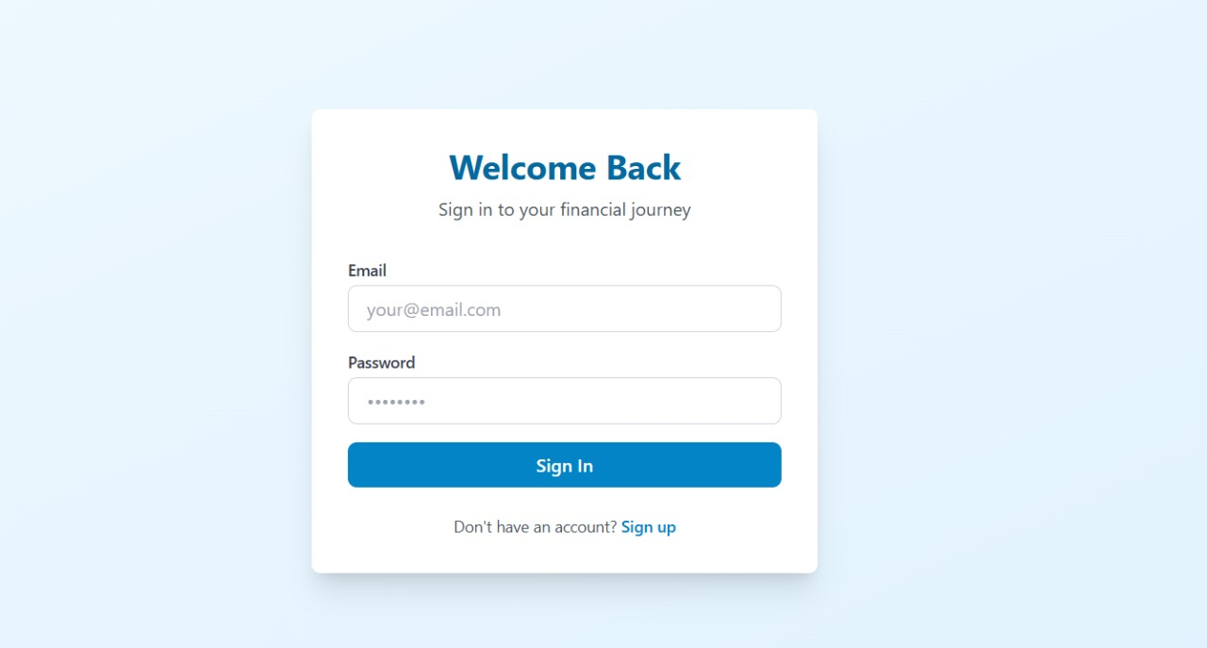

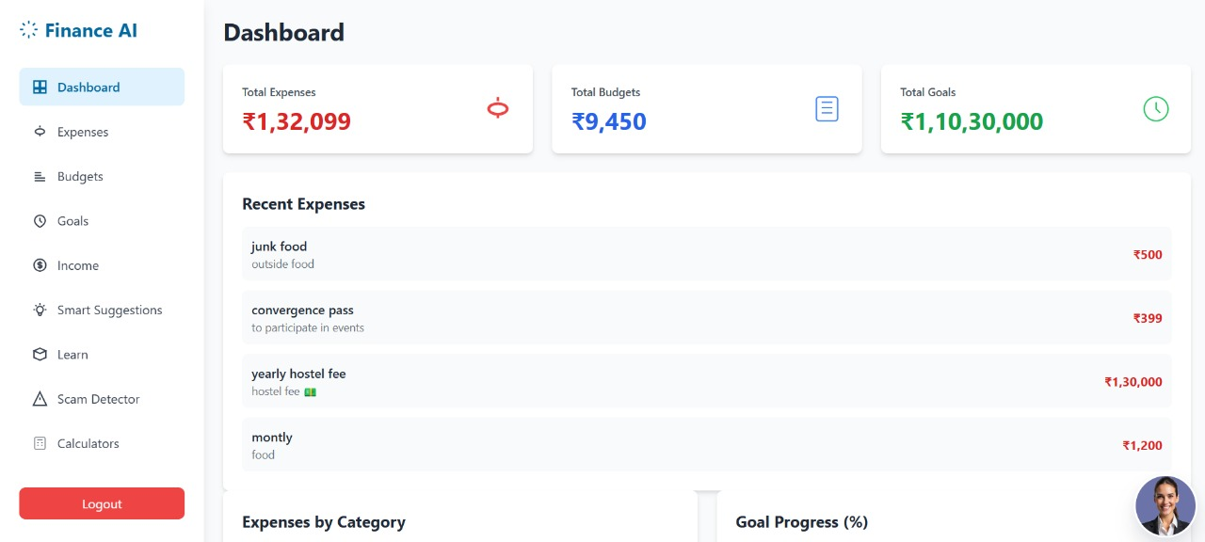

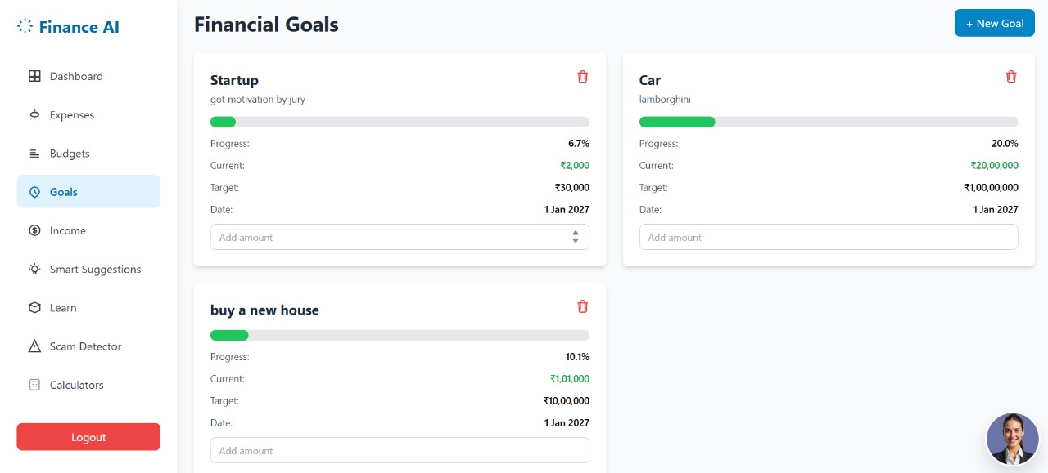

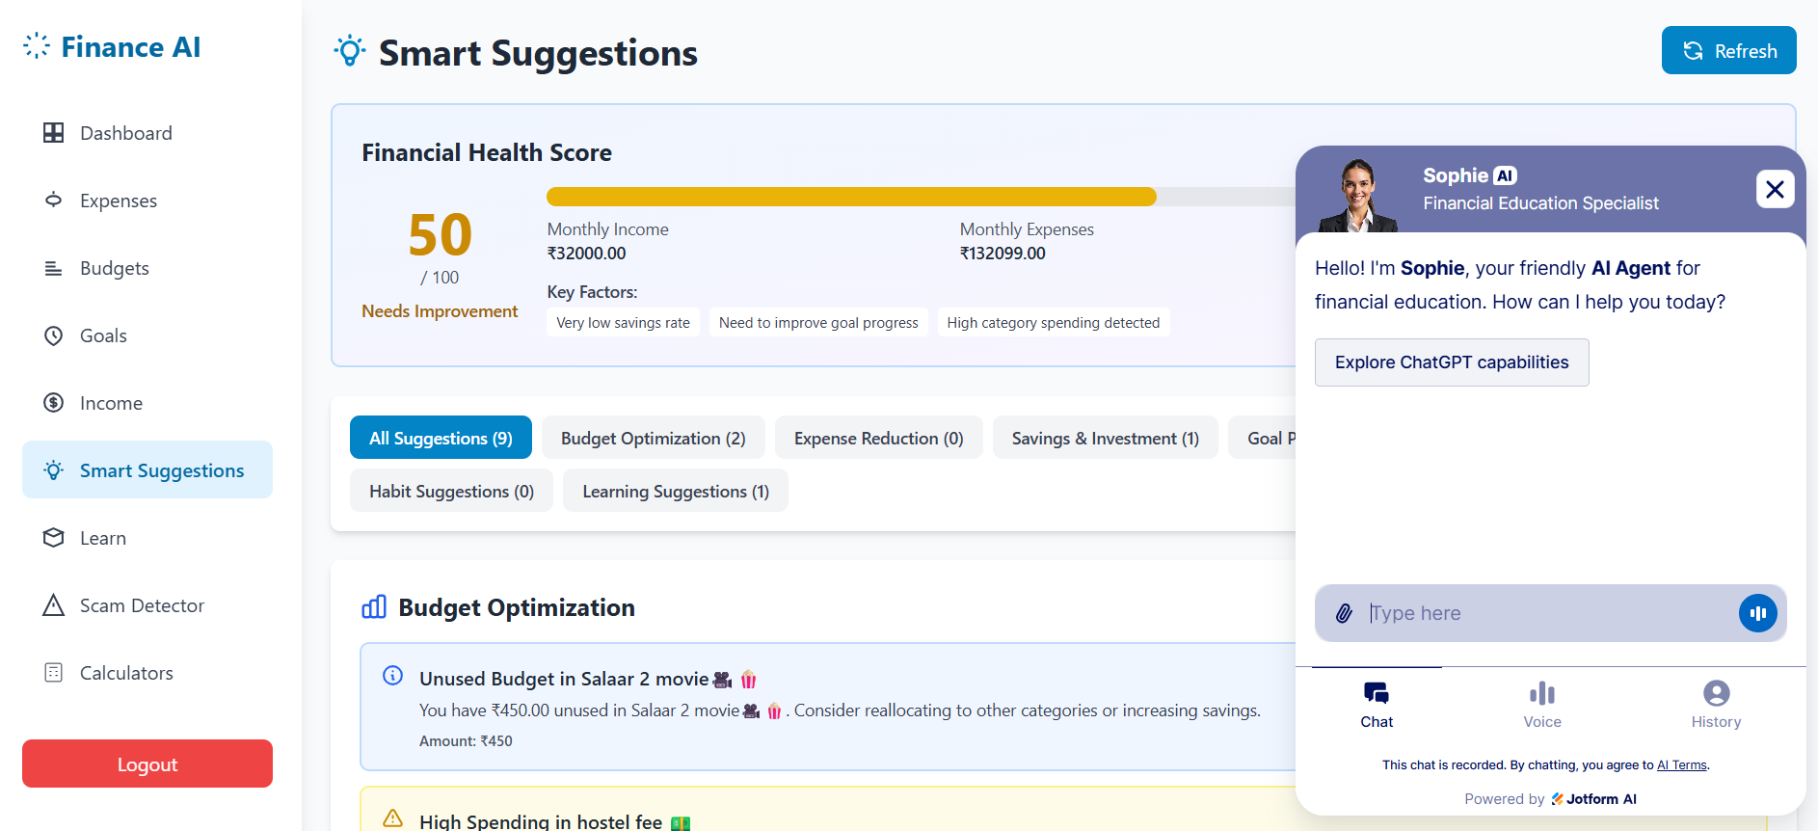

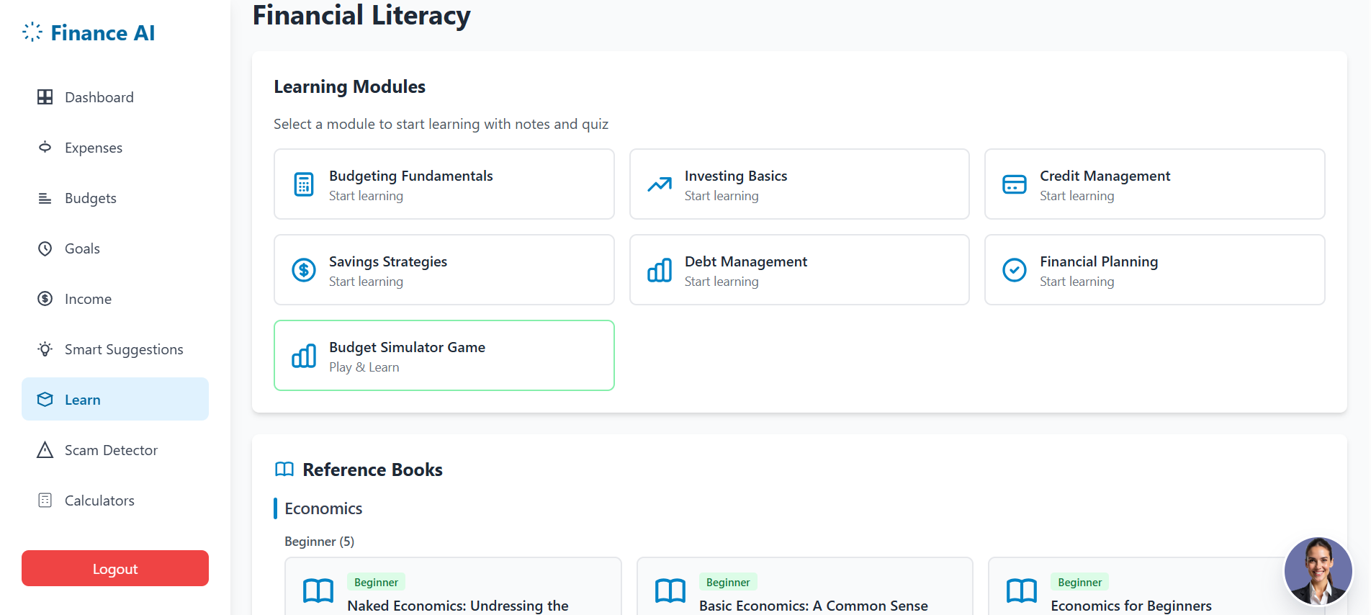



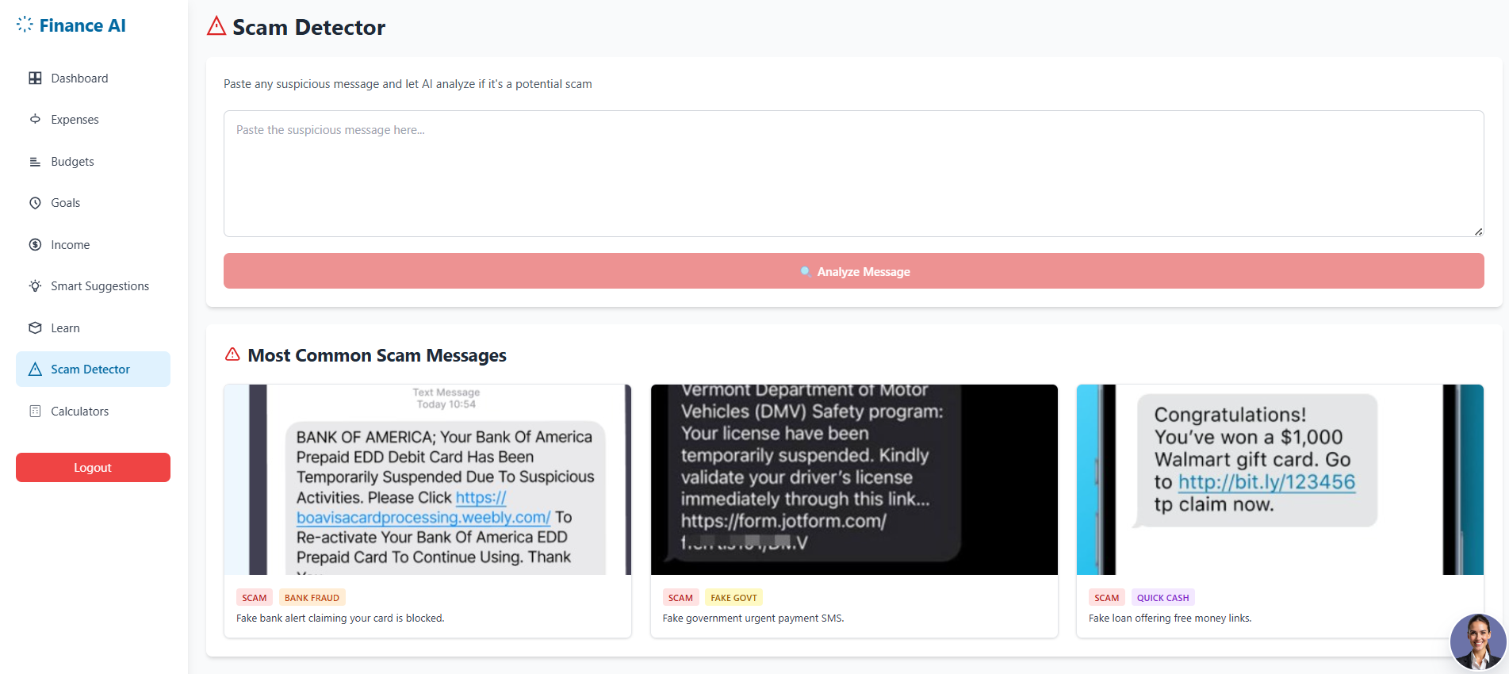

6. FUTURE SCOPE

6.1 Advanced AI Personal Finance Advisor

Future versions of the platform can integrate more sophisticated AI models capable of predicting long-term financial risks, analyzing investment choices, and offering deeper personalized guidance. This will make the platform more adaptive to individual user behavior and financial health.

6.2 Integration With Banking & Investment Platforms

The system can be enhanced to connect directly with real bank accounts, UPI apps, and investment platforms. This would allow automatic expense tracking, portfolio analysis, and real-time balance updates, offering users a complete financial management ecosystem.

6.3 Smart Notification & Alert System

An intelligent reminder system can alert users about bill payments, saving goals, spending limits, fraud risks, and investment opportunities. Context-aware alerts will greatly improve financial discipline and user engagement.

6.4 Multi-Language & Regional Support

To make financial education accessible to a wider audience, the platform can support multiple Indian languages and regional financial scenarios. This will help students and young adults from various backgrounds understand and apply financial concepts easily.

6.5 Expanded Learning Modules & Certifications

Additional gamified modules on taxation, insurance, loans, and digital finance can be included. The platform can also offer certification-based learning paths in collaboration with schools, colleges, or financial institutions to make the program more impactful.

7.CONCLUSION

The financial literacy platform successfully demonstrates how technology can simplify and enhance financial education for students and young adults. By integrating gamified learning, real-time financial simulators, expense tracking, and AI-based mentoring, the system makes financial concepts easier to understand and apply in daily life. The use of React for the frontend and Supabase for the backend ensures smooth performance, secure data handling, and reliable real-time updates. Features like UPI deep-link payments, fraud-awareness tools, and personalized insights further strengthen the platform’s practical impact. Overall, the project provides an effective, engaging, and accessible solution that empowers users to make informed financial decisions and build long-term financial confidence.

8.REFERENCES

- Reserve Bank of India (RBI). Financial Literacy Guide.
https://www.rbi.org.in/financialeducation/FinancialLiteracyGuide.aspx
- OECD. Financial Education for Youth: The Role of Schools.
https://www.oecd.org/content/dam/oecd/en/publications/reports/2014/04/financial-education-for-youth_g1g1c3eb/9789264174825-en.pdf
- OECD. Financial Education – Topic Overview.
https://www.oecd.org/en/topics/sub-issues/financial-education.html
- Reserve Bank of India (RBI). Financial Education (General).
https://www.rbi.org.in/financialeducation/
- OECD & G20/INFE. Core Competencies Framework on Financial Literacy for Youth.
https://www.fo-der.org/wp-content/uploads/2019/05/6.-Core-Competencies-Framework-Youth.pdf
- Government of India. National Strategy for Financial Education 2020–2025.
https://socialwelfare.vikaspedia.in/viewcontent/social-welfare/financial-inclusion/financial-literacy/national-strategy-for-financial-education-20202025?lgn=en

